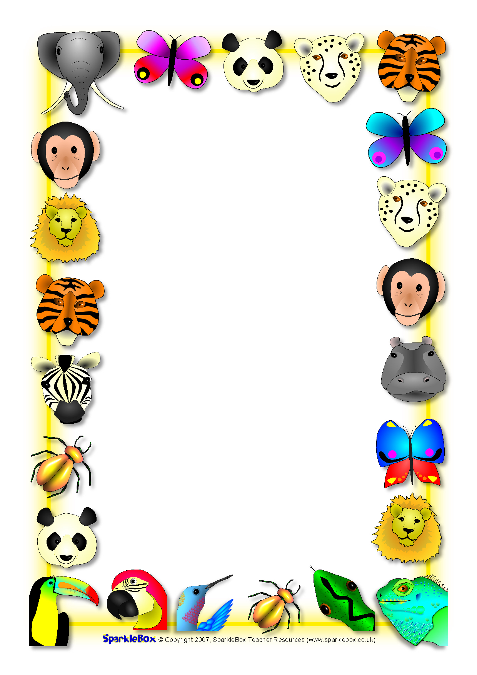

**Big Zoo Lesson DVD Order Form**

**The DVDs were filmed by East Lansing Public Schools. The cost to purchase the DVD is $5. The DVD running time is 33 minutes.**

**---------------------------------------**

**Child’s Name ___________________**

**______ # of DVDs to order**

**_____DVDs x $5 per DVD= $_______**

**(total)**

**\*\*Please pay in exact change or make checks payable to *East Lansing Public Schools.* \*\***

***Please return order form by Tuesday, December 3rd.***